# Hans Alberto Franke

## Date: 20/11/2020

## 2.1 Querying datasets

Each task is comment in the python code inside the scrip file: explore_bag.py.

### Task: Print the number of layers included in the dataset.

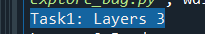

### Task: Print for each layer the layer name and CRS.

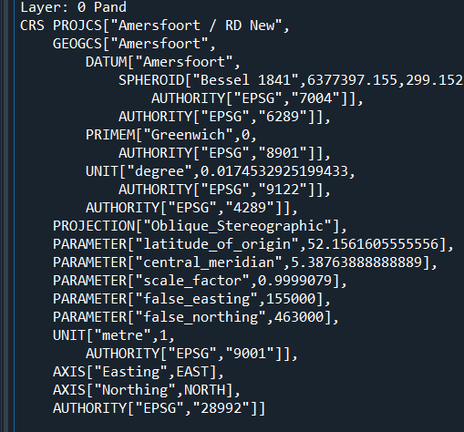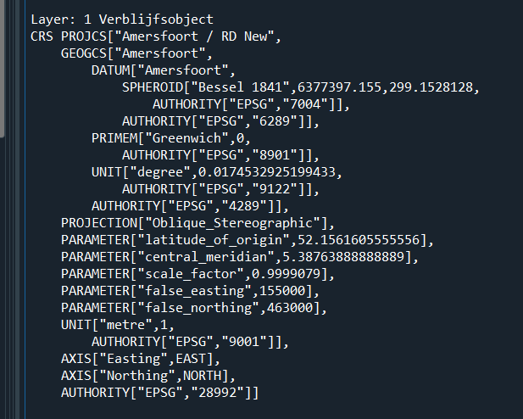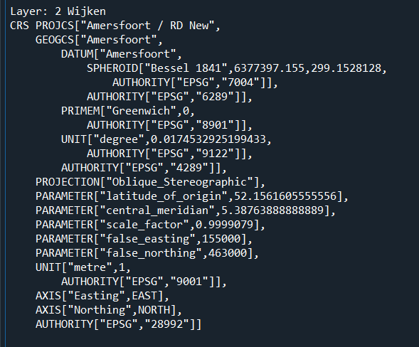

### Task: Print the number of features in the layer.

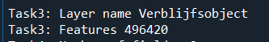

### Task: Print the name and type of each field in the layer.

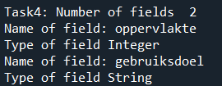

### Question: What is the total surface area given in the location layer?



### Question: What is the coordinate of the feature with the index 439774?

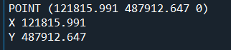

## 2.2 Obtaining building properties

Each task and question is commented in the python code. Filename: building_surface_area.py

### Task: Add a field area to your layer centroids

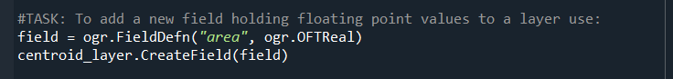

### Task: Calculate the area and the centroid location of each building.

Final map: purple points are the centroids, and the green polygons represents de buildings. The map was zoom in to see the both representations. The background of the map is the PDOK map of Netherlands. CRS = EPSG: 28992.

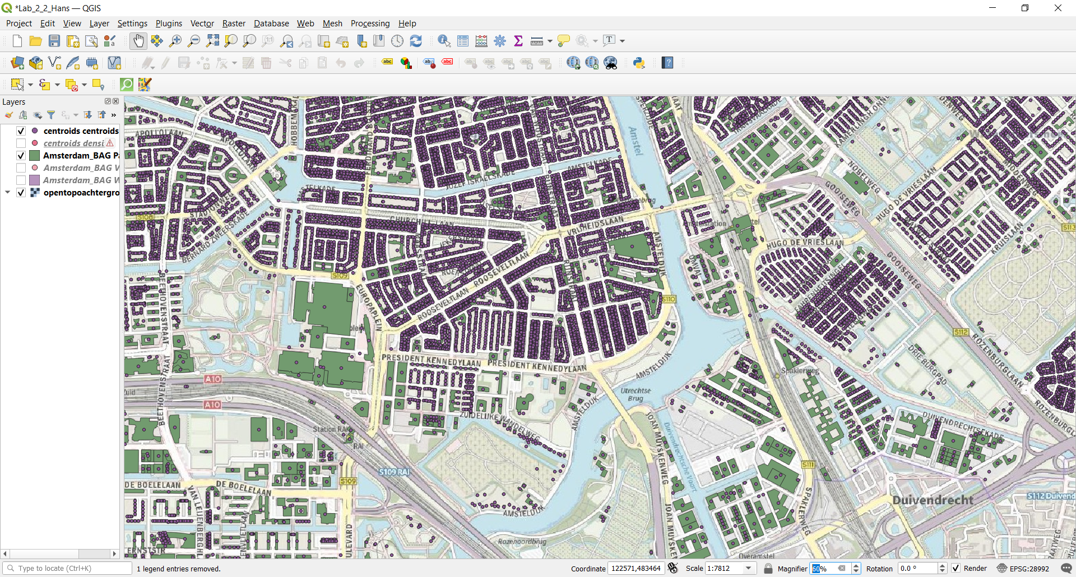

## 2.3 Computing building densities

### Question: What is the density of the district with feature id 54 (Museumkwartier)?

Looking in QGIS to check!

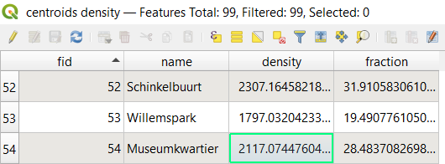

Script in Python to get the same results as GIS:

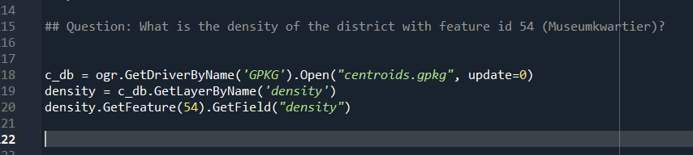

# 3.1 Retrieving school data

File: get_school_data.py

Request Parameters: PO = Primary Schools

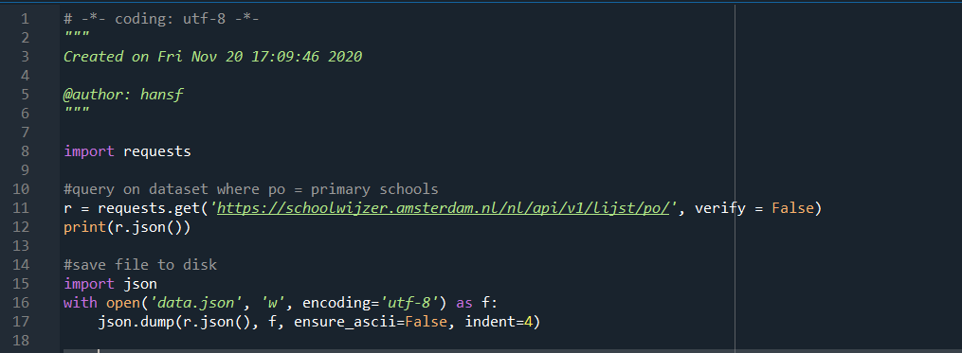

# 3.2 Constructing point geometries

### Task: Complete your Python script to create the school layer and run it.

Map with the results. Pink points = school locations. Yellow polygon = districts. Background = PDOK of Amsterdam. CRS = EPSG 28992

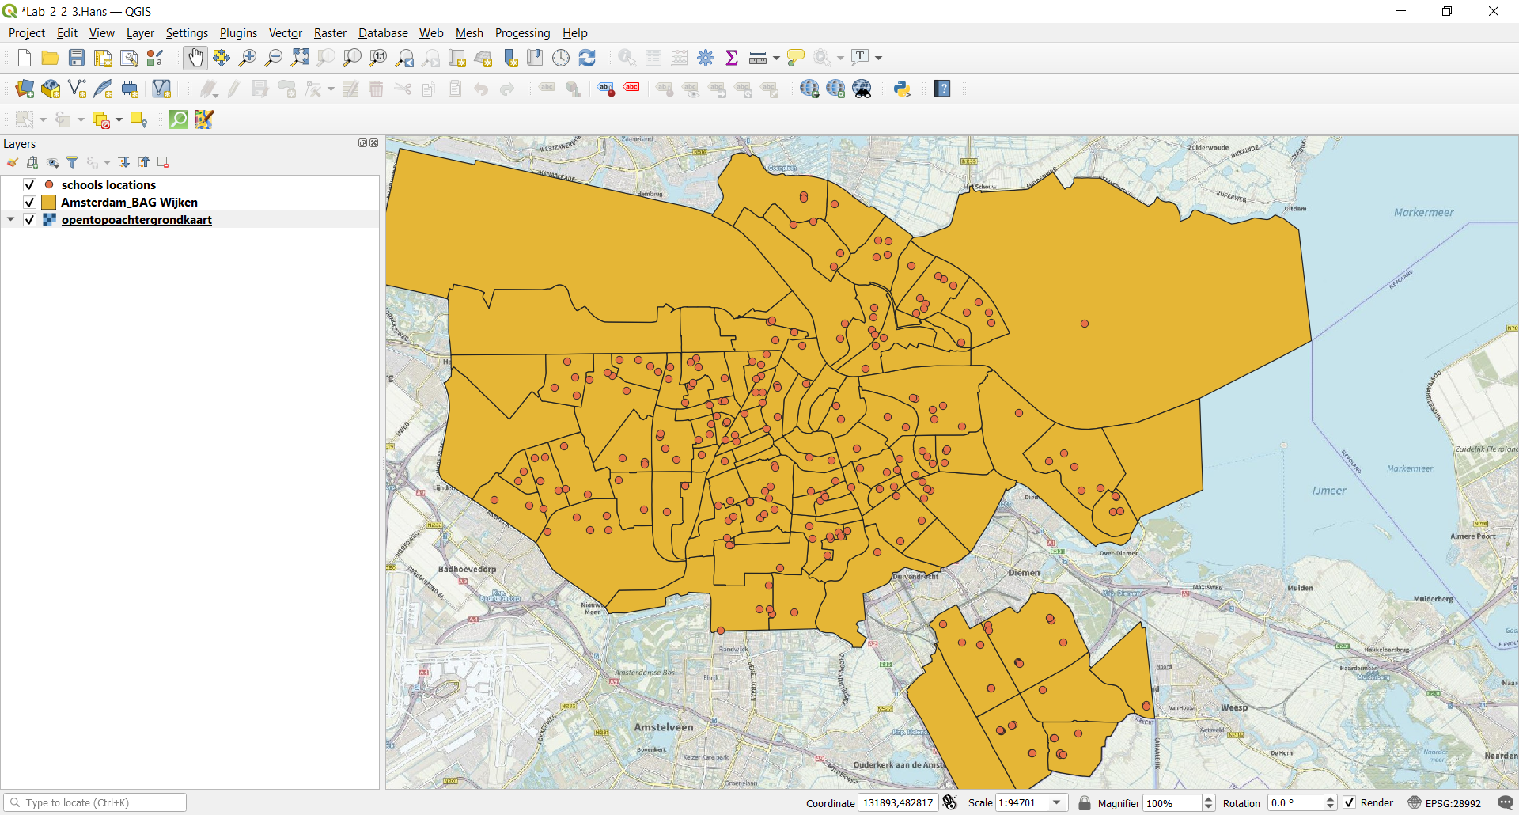

# 3.3 Adding buffer areas around schools

## Question: What is the geometry type of the layer buffer?

I chose polygons:



And confirmed in python code, when you add a buffer_distance to a point it becomes a polygon.

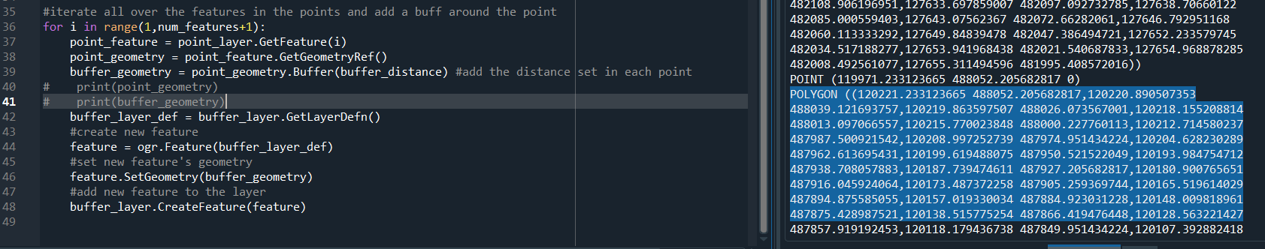

### Task: Create new features for the buffer geometries and add them to the buffer layer.

You can see that the points have a brown “circle” outside, this is the buffer area.

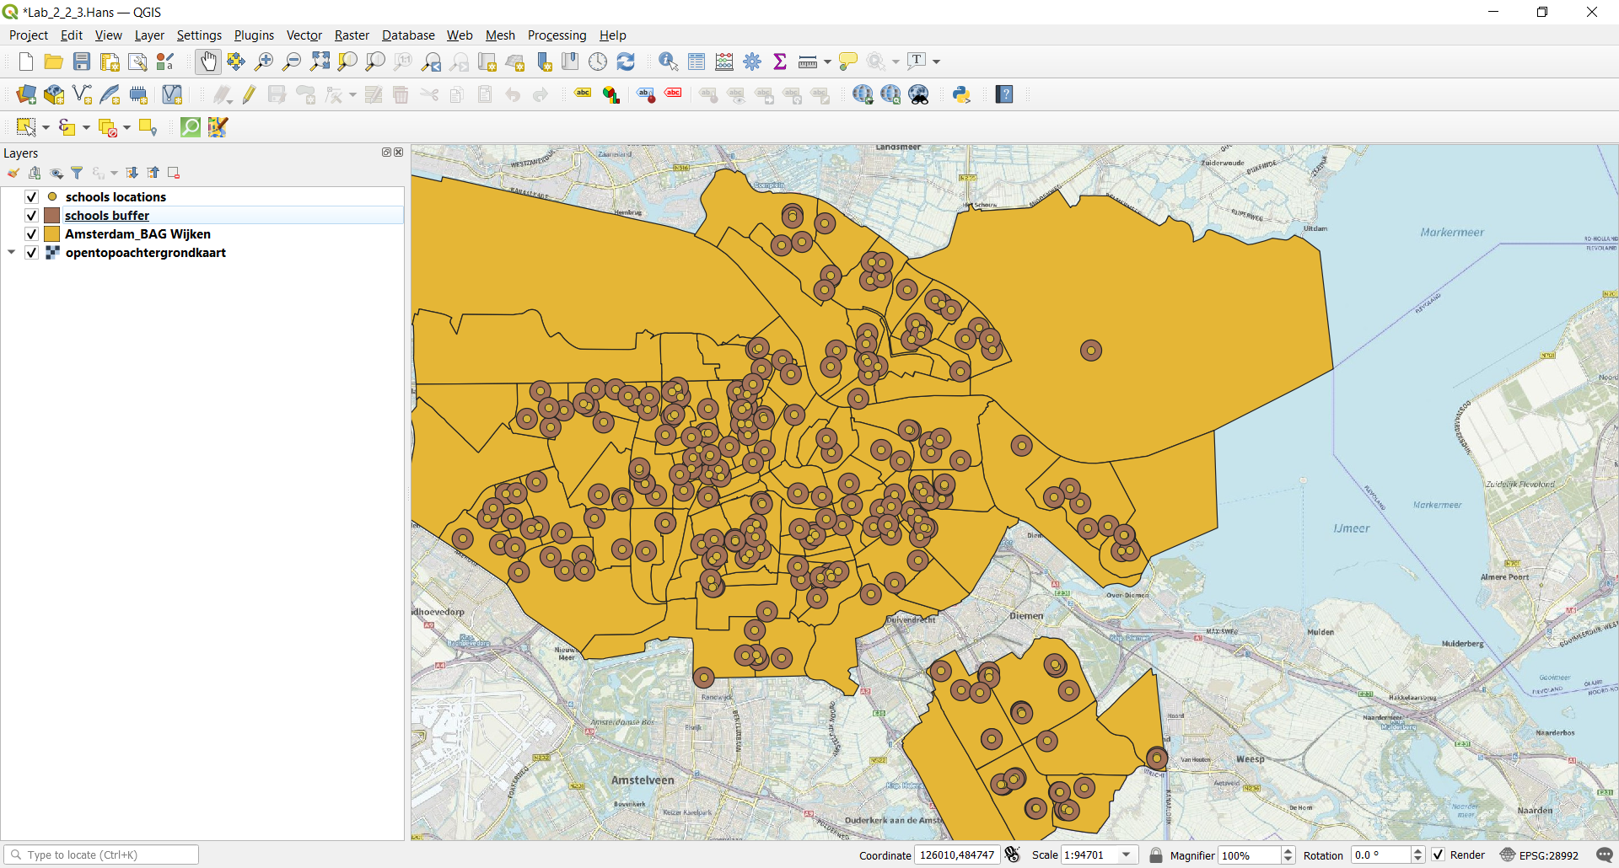

# 3.4 Merging geometries

### Question: What is the geometry type of the layer merge?

MultiPolygon, because it will store a sum of many polygons (the buffers)



Showing the map in QGIS:

Now you see the buffers merged as a multipolygon.

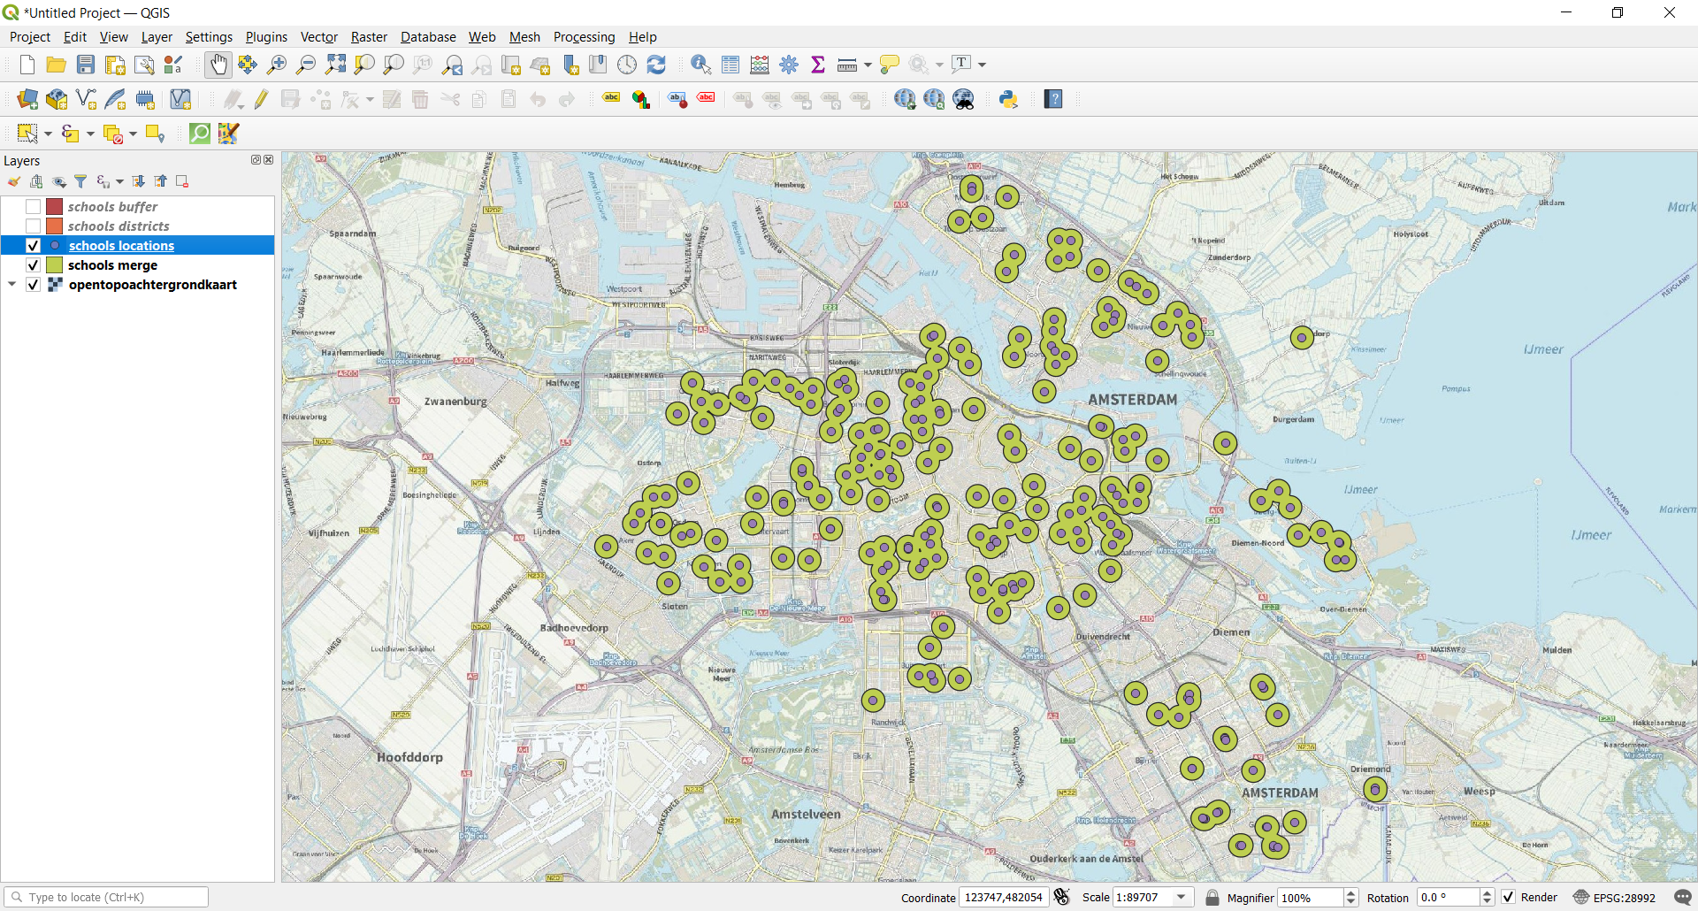

### Task: Create a second script merge_districts.py to merge the districts from the Wijken input layer of the Amsterdam_BAG.gpkg dataset. Merge the district geometries to one new geometry and add the result to the schools. gpkg dataset as the new layer districts.

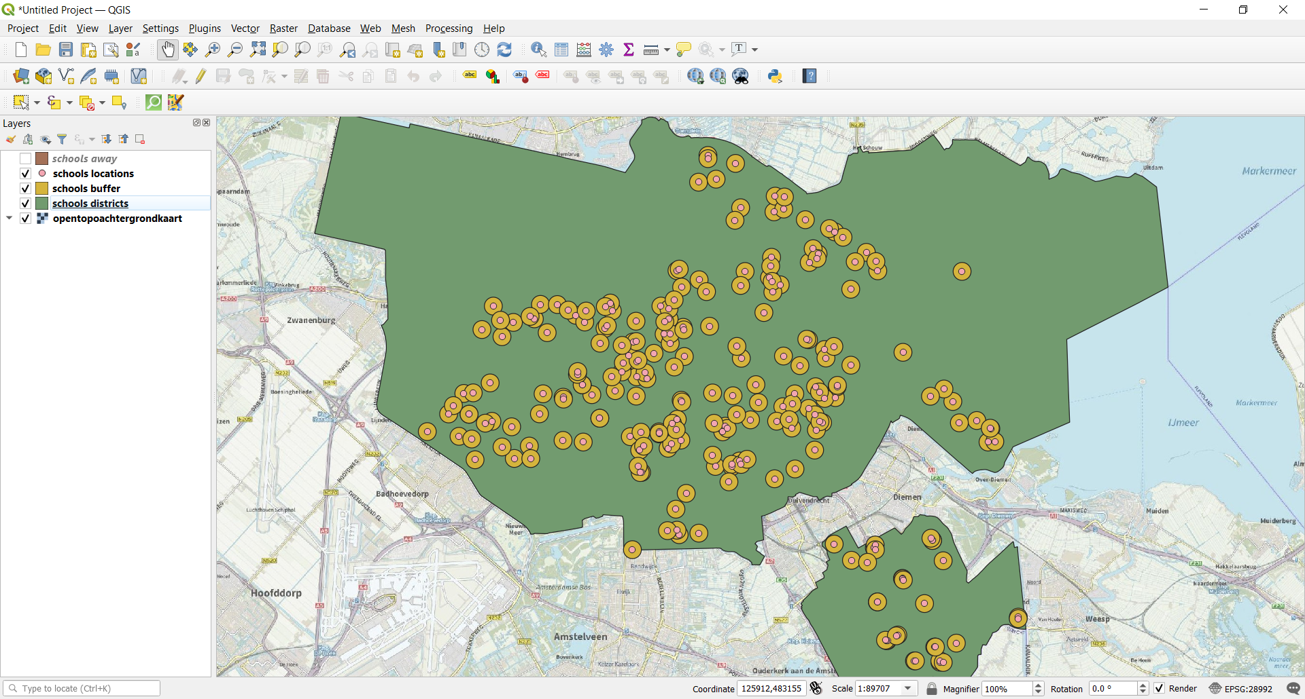

# 3.5 Compute area far from schools

### Question: Which operation will you use to compute the area far away from schools?

d) Difference

### Python Code:

### *districts_layer.SymDifference(merge_layer, away)*

### Returns an object that contains every point in either g1 or g2 but not the points that are in both g1 and g2. g1 and g2 should have the same dimension. Equivalent to the UNION of the DIFFERENCEs of g1, g2 and g2, g1.

### Question: What is the size of the area considered as far away from public schools?

The area considered far away from schools is (m2): 186648064.65494493

# Appendix: Scripts

Filename: LAB_2_2_Scripts_HansFranke.rar



Below there is the code paste for each file.

Explore_bag.py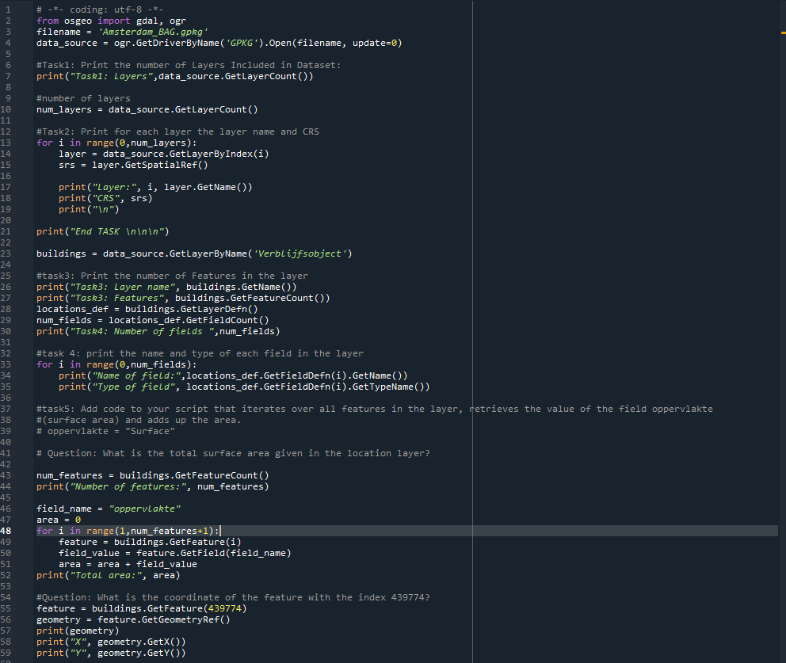

Building_surface_areas.py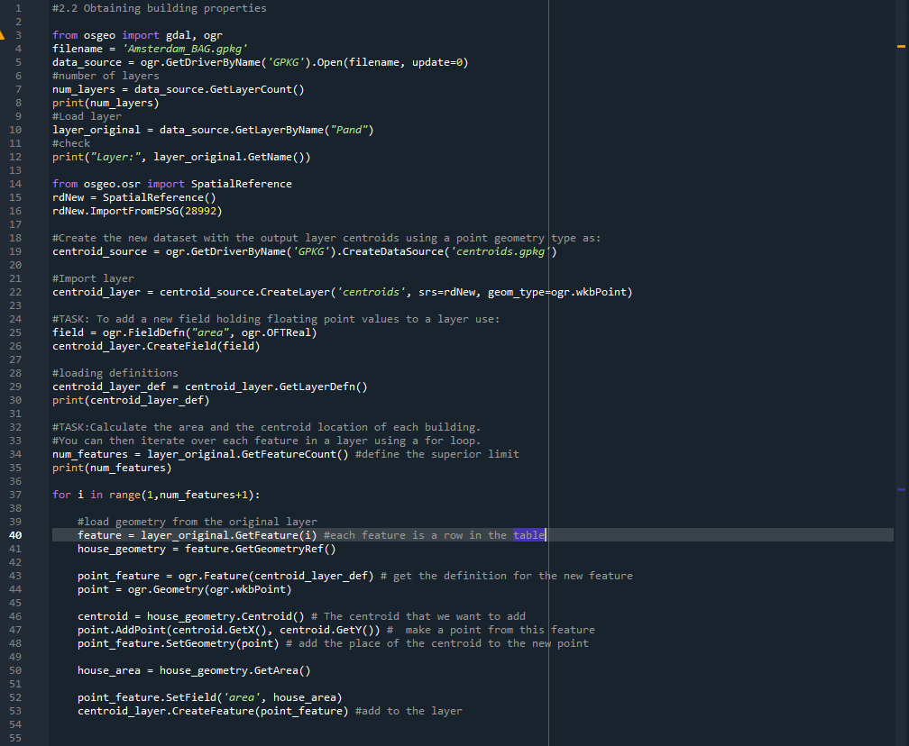

## Densities.py

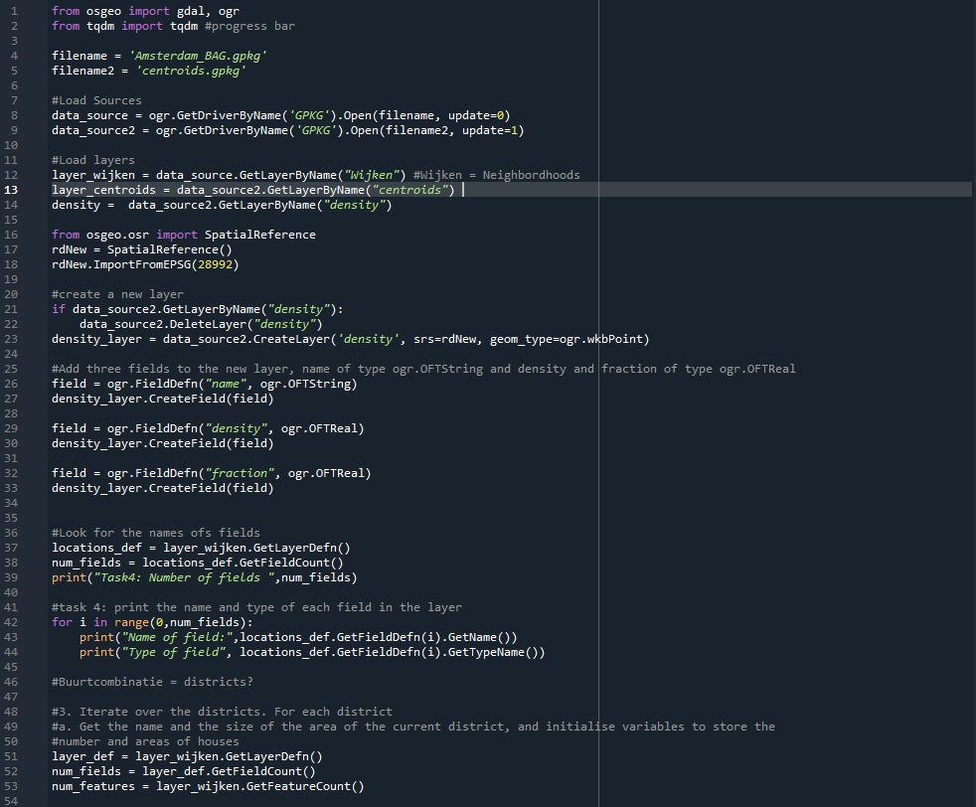 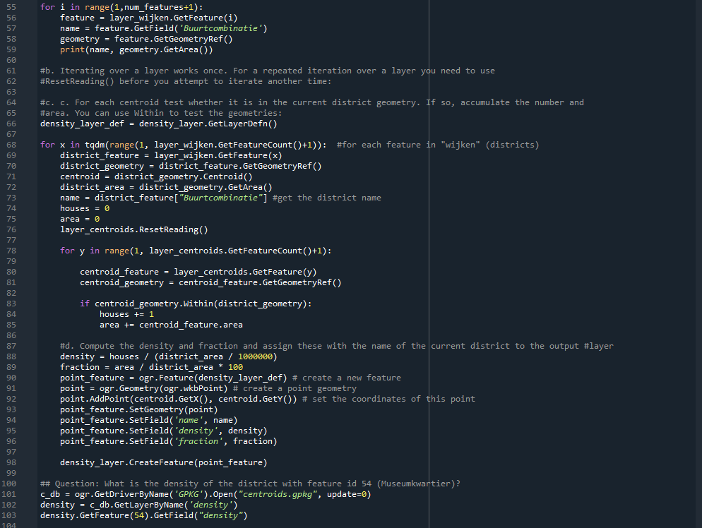

## Get_school_data.py

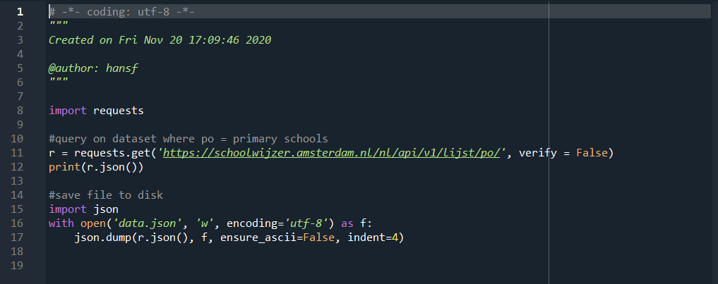

## Convert_json.py

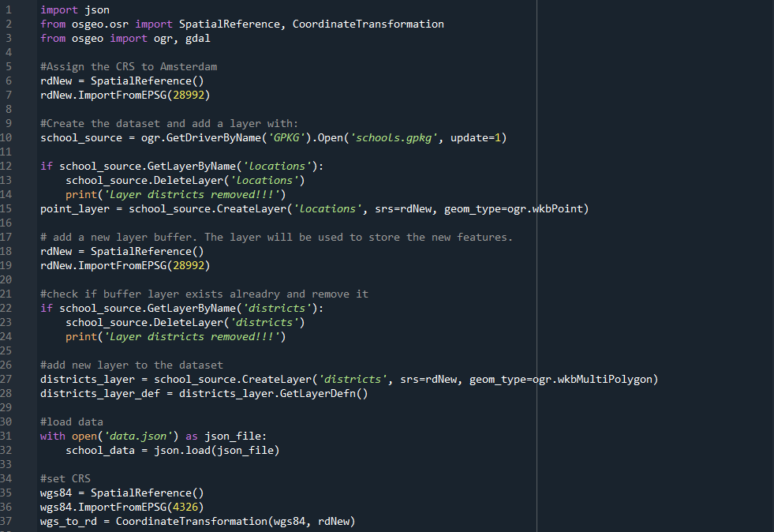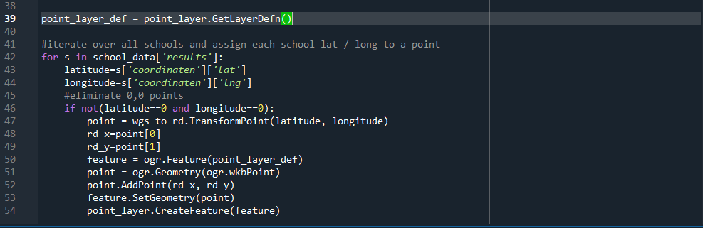

## Create_buffer.py

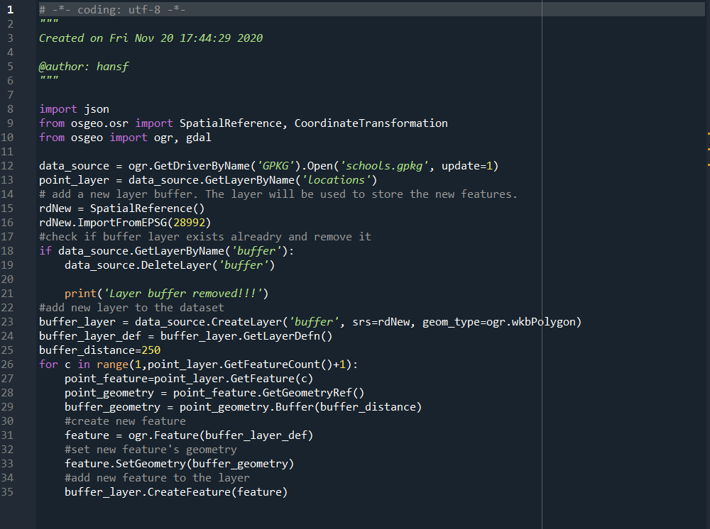

## Merge_buffer.py

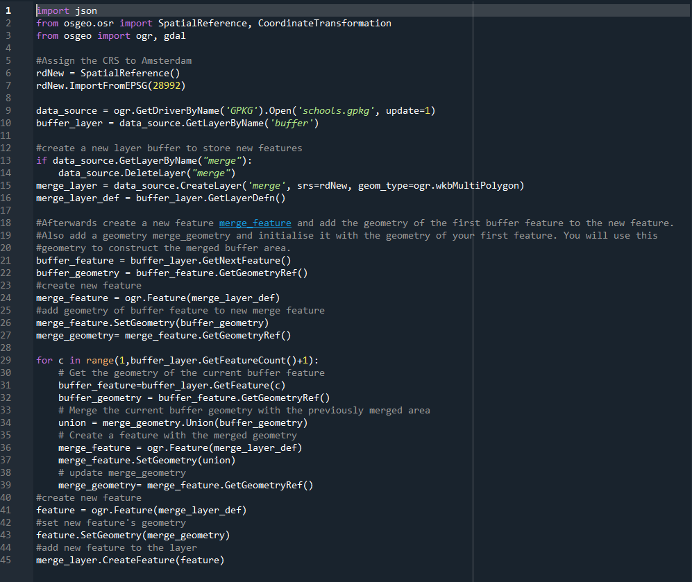

Merge_discrit.py (school_away is in the same code!)

